Software Engineering Lab Report II

**Infrastructure Management**

Pavan Vachhani (16CO151)

Kaushik I (16CO120)

February 02, 2018

# 1. Context Diagram

## Context Diagram:

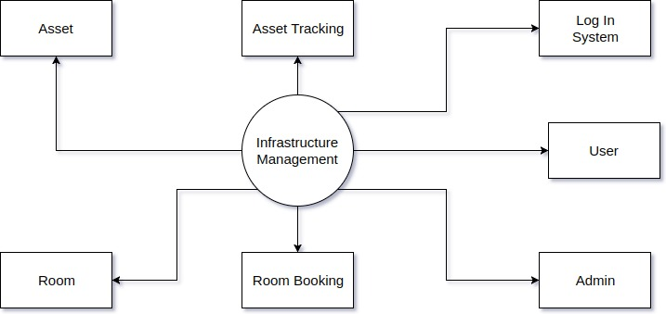

## Description of the entire system:

The Infrastructure Management software will have 7 main modules as shown in the context diagram. The Log-In system will manage the authentication of User, Admin or Super Admin (System Manager) and some help about the software and log in. Mainly there will be two roles using the software, which are User and Admin. These modules will manage, update and save their details. They will also provide interface to the software for each member. Asset and Room modules will help create, update and delete rooms or assets by authorized member. Room Booking module will manage the booking and approval of the rooms and assets in that room. It will provide the form to book the room and issue assets, help check availability of rooms etc. Asset Tracking module will help in tracking the assets for analysis and report after specific intervals of time (like every year).

The user will log in to the system and search for availability of room. User will then fill up the room booking form with list of assets required. This request will be sent to the admin to approve in Admin Module. If admin approves the request, it will show on the user’s page in User Module. Admin can search and list all the assets available from Asset tracking module. Super Admin can create new rooms and assets from Room or Asset module.

# 2. Data Flow Diagram

## 2.1 Data Flow Diagram

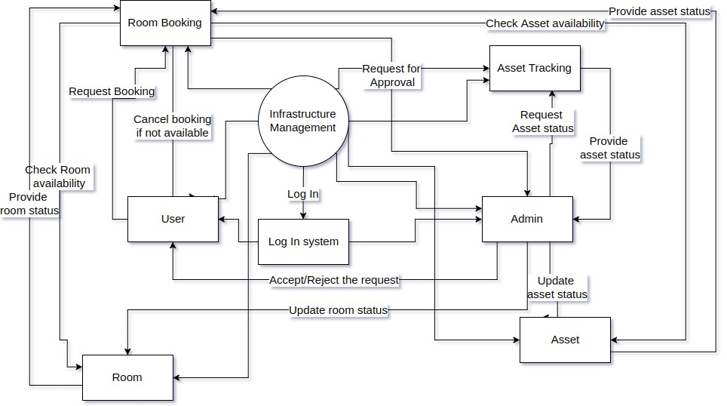

Level - 1 DFD

Above shown diagram shows Level – 1 DFD showing the data flow among the major modules.